

AMITY UNIVERSITY BENGALURU

SOURCE CODE MANAGEMENT

LAB MANUAL

SUBMITTED TO:-DR.MONIT KAPOOR

SUBMITTED BY:-SPOORTI GUNDEKAR

ER.NO:-A866175124024

SL.NO | INDEX
1. | BASIC OF LINUX
2. | INTRODUCTION GIT BASH
3. | GIT BASH AND GIT HUB
4. | FILE CREATION WITH COMMIT AND PUSH COMMAND
5. | BRANCHES CREATION
6. | MERGE REQUEST
7. | OPEN AND CLOSE PULL REQUEST
8. | COMPLETE GIT PROCESS

EXPERIMENT-01:

BASICS OF LINUX

1.What is Linux?
Linux is family of free and open –source operating systems based on the linux kernel operating
Systems based on linux are known as LINUX distributions or distros.
Examples include Debian,Ubunutu,Fedora,Arch Linux and many others.
2.Linux Distribution(distors)
Different versions of Linux tailored for various needs:
UBUNTU-User-friendly,great for beginners.
- DEBIAN-Stable and well tested.
- FEDORA-Latest features,cutting edge.
- ARCH LINUX-Lightweight and customizable.
- centOS/RHEL-Used in enterprise environments.
3.Linux file system structure
Linux follows a hierarchial structure:
1.bin-essential binary programs
2.etc-configration files
3.home-user directories
4.root-root users home directory
5.var-variable data(log etc).
6.tmp-temporary files
7.usr-user-installed software.

4.BASIC LINUX COMMANDS
COMMAND DESCRIPTION
ls List files in a directory
cd Change directory
pwd Print working dircetory
mkdir make a new directory
rm remove files/directories
cp copy files/directories
mv move or rename files
cat display file content
sudo execute a command as superuser
man show manual/help for a command
5.FILE PERMISSION
- Linux controls file access with permissions.
- Use ls –l to view them(e.g,-rwxr-xr--).
- Modify with chmod,chown,or chgrp.
6.PACKAGE MANAGEMENT
- Install/update software using package managers.
- Debian/Ubuntu:apt(e.g,sudo apt install package-name).
- Red hat/Fedora:dnf or yum
- Arch Linux:pacman

7.SHELL TERMINAL
- The shell interprets commands (e.g., bash, zsh)
• Terminal is where you type the commands
8.USERS AND PERMISSION
- Manage users with adduser, usermod, and passwd.
- Regular users vs. root (superuser).

EXPERIMENT 2:-

Introduction -Git Bash

• What Is Git Bash?

Git Bash is a command-line tool for Windows that provides: Git command-line tools

• A Bash (Unix-style) shell

• A way to run shell commands similar to those used in

• Linux/macOS It's especially useful for developers using Git on Windows who want a Unix-like experience.

- Bash Emulation:
o Bash (Bourne Again SHell) lets you run Linuxstyle commands (e.g., ls, pwd, rm).
o This makes it easier to follow tutorials written for Linux/macOS.
- Git Integration:
o You can run Git commands like git clone, git status, git commit directly in Git Bash.
o Useful for version control and managing code repositories.
- Cross-Platform Compatibility:
o Lets Windows users interact with remote Linux servers or repositories more easily.
How to Install Git Bash:
1. Go to https://git-scm.com
2. Download the installer for your OS (choose Windows).
3. Run the installer and select “Git Bash” when prompted about default terminal.
4. After installation, right-click anywhere and choose “Git Bash Here” to open the terminal.
Command Description
Cd Change directory
mkdir myfolder Create a new folder
rm filename Remove a file
git init Initialize a new Git repository
git clone URL Clone a repository from GitHub
git status Show current Git status
git add . Stage all changes
git commit -m "message" Commit staged changes
Use Cases:
• Running shell scripts
• Navigating your project with Unix-style commands
- Automating development tasks
- Managing Git repositories
EXPERIMENT-03
Git Bash And GitHub

• 🧠 What is Git?
Before connecting GitHub and Git Bash, it’s important to know:
Git is a version control system to track changes in code.

GitHub is a hosting service for Git repositories.

• Git Bash lets you use Git on Windows with Linux-style commands.
How They Work Together Here’s the typical workflow:
1. You install Git and Git Bash on your Windows machine.
2. You create or clone a Git repository using Git Bash.
3. You make changes to your files locally.
4. You use Git commands in Git Bash to: o stage changes: git add o commit changes: git commit o push changes: git push (to GitHub)
5. You use GitHub to: o store your code in the cloud o collaborate with others o view project history, pull requests, issues, etc.
Example: Basic Workflow
Step-by-step using Git Bash & GitHub:
- Clone a GitHub repo:

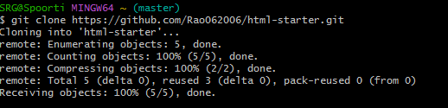

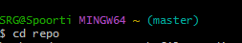
- Make changes to our project files
3.Stage and commit changes.
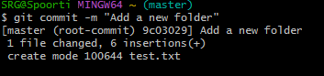

4.Push changes to GitHub.

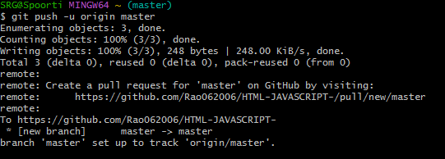

EXPERIMENT- 4:
- File Creation With Commit And Push Command.
To Create a file,commit it and push it to a remote¬ repository using Git Bash
1.Create a File.
Open Git Bash and create a folder .
Using cd and mkdir create a folder.
Then git init command to create a new Git repository
Create a new file using vi command in Linux is used to open and edit files using the vi editor, a powerful text editor available on most Unix-based systems.

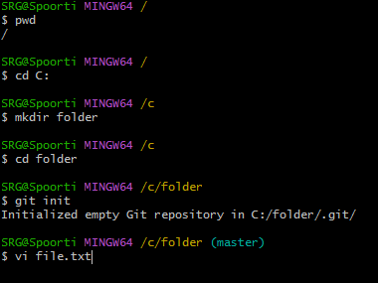
Now open the file and write:
Basic vi commands;
- Insert Mode: Press i to start editing.
- Save and Exit: Press ESC
- then type: wq to save and exit.
- Use :q! to exit without saving.

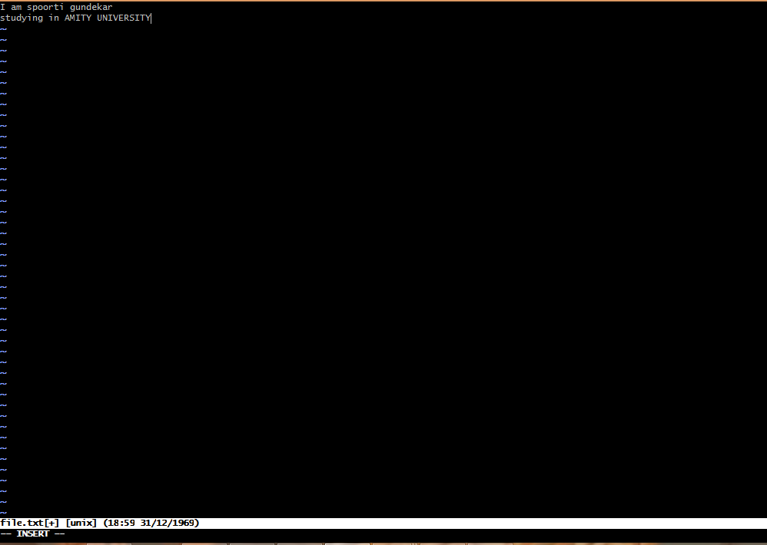
2.Add the File to Git:
Stage the file for commit
To add all files in the directory.
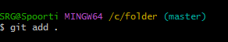
3.Commit the File:
Commit the changes with a message
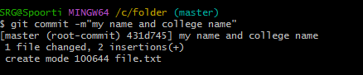
4.Add and push to remote repository:
Push the changes to Git Hub (assuming origin is the remote and main is the branch.)
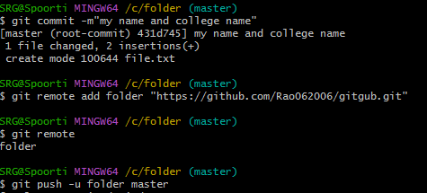
EXPERIMENT :5
Branches Creation
In Git branches allow developers to work on different features or fixes without affecting the main codebase.Here’s how we can create and manage branches.
Check the branches: Check the branches using git branch command.
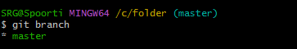
To create new branch ;
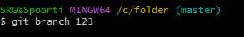
Switching to a Branch:
To switch to the newly created branch
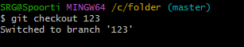
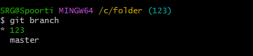
EXPERIMENT:6
Merge Request
A Merge Request(MR) is a feature used in Gitbased platforms like GitLab to propose and review changes before merging them into the main branch.It is similar to a Pull Request(PR) in GitHub.
How Merge Request Works:
1. Create a Branch A developer creates a separate branch from the main branch (often called main or master) to work on a specific feature, bug fix, or enhancement.
2. Make Changes
The developer writes code, commits changes to their branch, and pushes the branch to the remote repository.
3.Open a Merge Request
In the Git platform (e.g., GitLab, GitHub):
The developer opens a merge request from their feature branch into the target branch (usually main). They add a description, possibly link related issues, and assign reviewers.
4.Code Review Reviewers
(team members or maintainers) review the code. Automated checks (e.g., tests, linters) are run via
CI/CD pipelines. Feedback might be given; the author can make
additional commits to address it.
5.Merge The MR is merged into the target branch:
Options include merge, squash and merge, or rebase and merge.
Once merged, the feature branch can be deleted if no longer needed.
Steps to Merge the Branch:
1.Switch to the main branch (master):

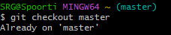
2.Merge the branch:
Using git mergetool and git merge main command.

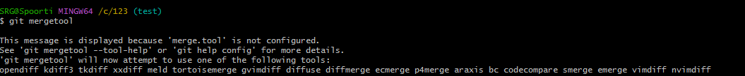
To remove merging commit one line:
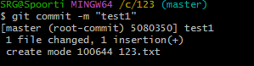
Using the command graph we can see the graph of commits:
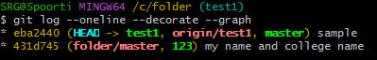
Benefits:
- Facilitates code review
- Triggers automated tests
- Maintains a clear change history
- Encourages collaborative development
EXPERIMENT-07:
- Open and Close Pull Request
1.OPEN AND PULL REQUEST
1. Push your changes to a branch on your fork or the same repository.
2. Go to GitHub, navigate to the repository.
3. You’ll see a “Compare & pull request” button — click it.
4. Add a title and description for your PR.
5. Click “Create pull request
2. CLOSE A PULL REQUEST
1. Click “Merge pull request”.
2. Confirm by clicking “Confirm merge”.
3. Optionally, delete the branch. In the git hub account select the user which whom you want to merge and select the repo and fork it:
Now copy the link and using git clone command open that file: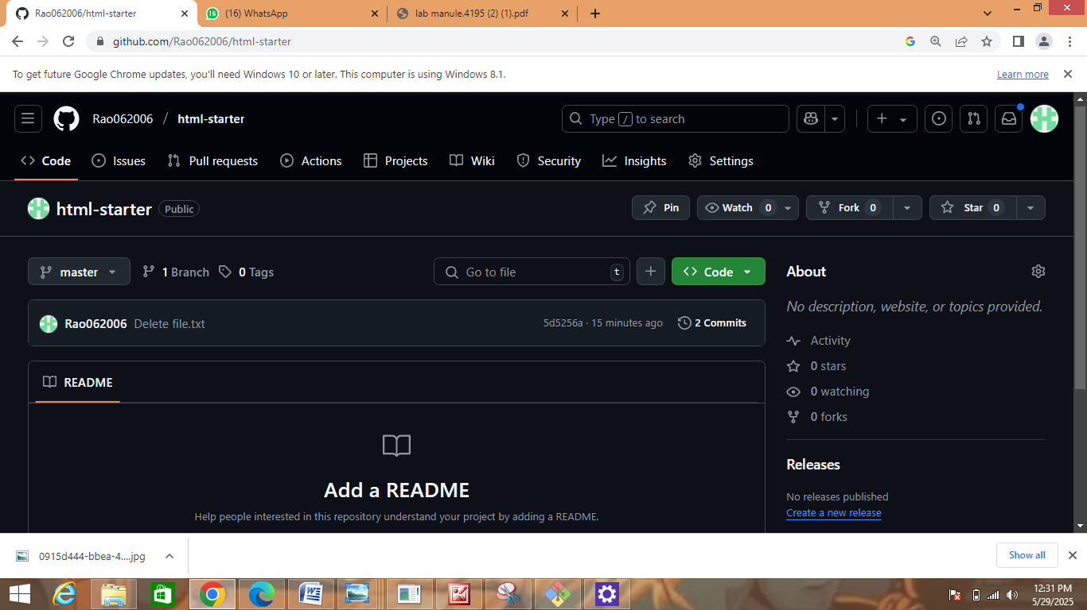
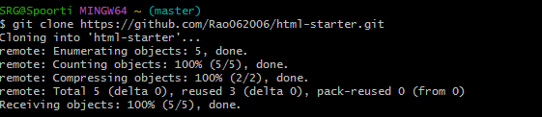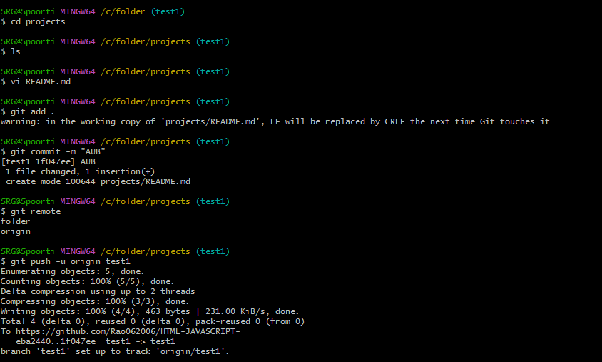
Steps to Close a Pull Request on GitHub:
1. Go to the repository on GitHub.
2. Click on the "Pull requests" tab.
3. Find the pull request you want to close and click on it.
4. Scroll to the bottom of the PR page.
5. Click the “Close pull request” button.
EXPERIMENT-08:
Complete Git Process.
- Install Git Bash
Download Git for Windows from Git's official website.
Run the installer and follow the setup instructions.
Choose Git Bash as the default terminal option.

2.Initialize a Repository

Open Git Bash and navigation to our project folder.

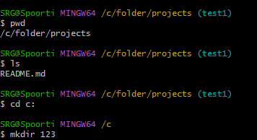

Initialize a new git repository
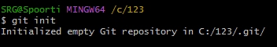

3.Create and Modify Files

Create a file using vi command:
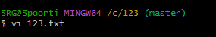
4.Check Repository Status

View changes
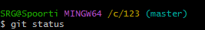
5.Stage and Commit Changes
Add files to the staging area
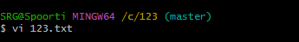
Commit changes:
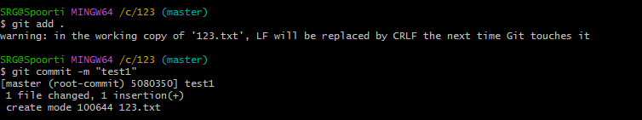
7. Create and Manage Branches
Create a new branch:
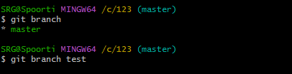
Switch to the branch:
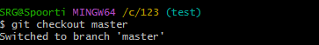
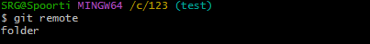
Merge the branch into the main branch:
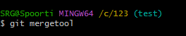
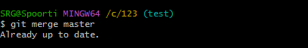
8.Git clone
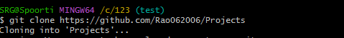
9. Pull Changes from Remote Repository
Update local repository:
10. Pull Changes from Remote Repository
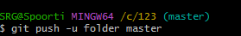
11.Open and Close Pull Requests
Open a Pull Request on GitHub and merge changes.
Close the Pull Request if needed.

